**Sending CLS dashboards as Email Attachments**

Watcher is an Elasticsearch feature that can be used to create actions based on conditions, which are periodically evaluated using queries on your data. Watches are helpful for analyzing mission-critical and business-critical streaming data. For example, you might watch application logs for performance outages. This feature can also be used for sending CLS dashboards as attachments in an email.

1. Watcher can be accessed in CLS using options below.

* Search “Watcher” in the “Search Elastic” box.
* Click on Menu icon on the left and choose “Management” and then “Stack Management”. “Watcher” option should be in “Alerts and Insights” section.

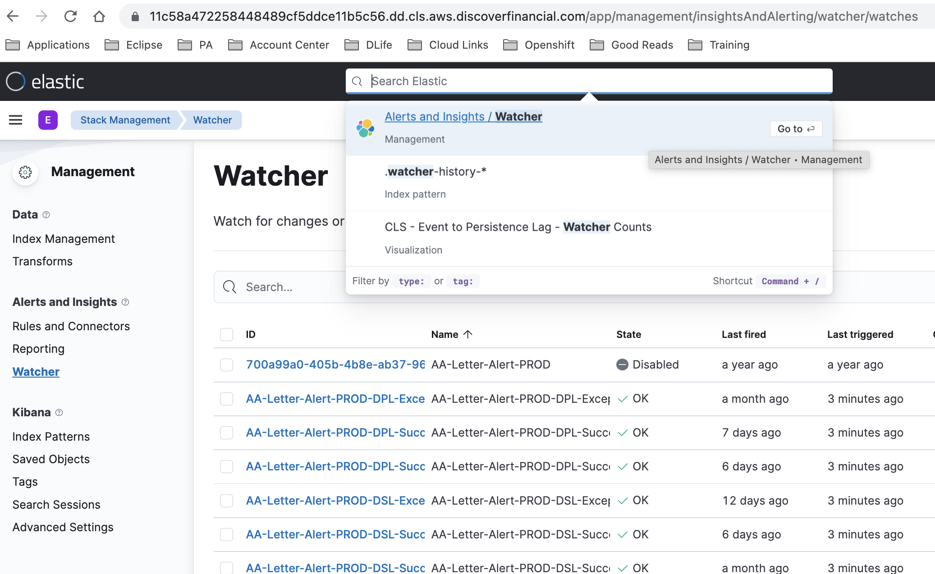

1. Click on “Create” and choose “Create advanced watch”. It will open a default script which you can start editing for incorporating your changes.

1. Here is the sample script that gets executed at 8am CT.

{

"trigger": {

"schedule": {

"daily": {

"at": [

"13:00"

]

}

}

},

"input": {

"none": {}

},

"condition": {

"always": {}

},

"actions": {

"email_1": {

"email": {

"profile": "standard",

"attachments": {

"<EMAIL_ATTACHMENT_NAME>.png": {

"reporting": {

"url": "<DASHBOARD_URL>",

"retries": 40,

"interval": "15s",

"auth": {

"basic": {

"username": "<YOUR_CLS_USERNAME>",

"password": "<YOUR_CLS_PASSWORD>"

}

}

}

}

},

"to": [

"<EMAIL_IDS>"

],

"subject": "<EMAIL_SUBJECT>",

"body": {

"html": "<EMAIL_BODY>"

}

}

}

}

}

1. DASHBOARD_URL in the above script can be obtained as below. Click on “Share”. Select “PNG Reports” / “PDF Reports” -> “Advanced Options” -> “Copy POST URL”.

1. Similarly, CLS can also trigger alerts when it finds a specific word (Eg. Exception) for more than a given number of times in the application logs. Here is the reference script. This script runs for every 10 minutes.

{

"trigger": {

"schedule": {

"interval": "10m"

}

},

"input": {

"search": {

"request": {

"search_type": "query_then_fetch",

"indices": [

"logs-slam-eclipse-org-*"

],

"rest_total_hits_as_int": true,

"body": {

"size": 0,

"query": {

"bool": {

"must": [

{

"match_phrase": {

"message": "Exception"

}

}

],

"must_not": [

{

"match_phrase": {

"message": "PartyId can not be NULL"

}

},

{

"match_phrase": {

"message": "Consumer exception"

}

}

],

"filter": [

{

"range": {

"@timestamp": {

"gte": "now-10m",

"lt": "now"

}

}

}

]

}

}

}

}

}

},

"condition": {

"compare": {

"ctx.payload.hits.total": {

"gte": 50

}

}

},

"actions": {

"my-logging-action": {

"logging": {

"level": "info",

"text": "{{ctx.payload.hits.total}} exceptions found in last 10 mins in eclipse index"

}

},

"send_email": {

"email": {

"profile": "standard",

"to": [

"<YOUR_EMAIL>"

],

"subject": "High number of exceptions reported in last 10 minutes in Eclipse Index.",

"body": {

"text": "{{ctx.payload.hits.total}} exceptions found in last 10 mins"

}

}

}

}

}